5a, engleski jezik, 18.5.-22.5.
Hello everyone!!
Ponovo ćemo uvježbavati prošlo vrijeme, PAST SIMPLE.
Vidjela sam da ste iz povijesti učili o Rimskom carstvu. Kada govorimo o povijesti upotrebljavamo
Past Simple
Znate li što su rimski vojnici, legionari, jeli. What did the Roman soldiers eat?
maslinovo ulje
kaša
žita
vino
sol
Invicta They ate meat. They used olive oil. They ate wheat.
They ate vegetables. They drank wine. They ate porridge.
They ate cheese. They used salt. They made bread.

Crvene riječi su glagoli u prošlom vremenu. Prisjetimo se i niječnog oblika, ljubičaste riječi.
ate jeli su drank pili su used koristili su made pravili su
didn't eat nisu jeli didn't drink nisu pili didn't use nisu koristili didn't make –nisu pravili

U to vrijeme Rimljani nisu jeli neku hranu jer je ona mnogo kasnije donesena iz Amerike.
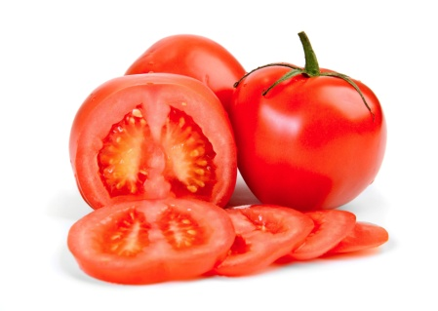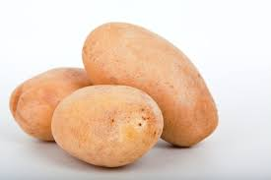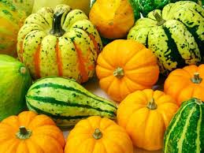
Roman soldiers didn't eat tomatoes. They didn't eat potatoes. They didn't eat pumpkins.

Ovo je pribor koji je svaki vojnik imao: posuda za kuhanje, noževi, žlice, glineno posuđe.
U to doba nisu imali vilice.
The didn't use forks. (Nisu upotrebljavali žlice)
They used saucepans.
They used knives and spoons.

ZADAĆA
Pročitajte ove rečenice o rimskim legionarima. Izaberite jesni (crveni) ili niječni ( ljubičasti) oblik. Prepišite točne rečenice u svoje bilježnice.
They eat didn't eat hamburgers. They drank didn't drink coca-cola.
They eat didn't eat hot-dogs. They travelled didn't travel by bus.
They eat didn't eat sandwiches. They used didn't use spoons.

Sljedeći tjedan govorit ćemo o životinjama.
Pogledajte ovaj video i zapamtite imena životinja. ZADAĆA: Prepišite imena životinja u svoju bilježnicu.
https://www.youtube.com/watch?v=p5qwOxlvyhk

Što vidiš? Vidim tigra.

Posjetite ovu stranicu i potražite zanimljive sadržaje: Dream English Kids

