5a razred, engleski jezik, 27.4. – 30.4.

Hello!
Podsjećam sve one koji još nisu prepisali rečenice u kojima se govori kakvo je vrijeme bilo koji dan, da ih prepišu, slikaju i pošalju na viber grupu 5a.
Da ponovimo:
Jučer = YESTERDAY prošlost | Danas = TODAY sadašnjost
It was Monday (Bio je ponedjeljak.) | It is Tuesday. (Utorak je)
It was sunny. (Bilo je sunčano) | It is windy. (Vjetrovito je.)
I was at home. (Bila sam doma.) | I am at home. (Doma sam.)
You were at home. (Bili ste doma.) | You are at home. ( Vi ste doma)

SADAŠNJOST am is are
PROŠLOST was was were

Otvorite radnu bilježnicu na 126. Str.
Ogovorimo zajedno na pitanja ispod prve slike. Upišite odgovore ( rečenice označene zelenom bojom) u radnu bilježnicu.
- Gdje je Anne bila jučer?
She was in bed.
- Je li bila sama?
Yes, she was.
- Gdje su bili njezini prijatelji?
They were in the park.
- Je li bila sretna?
No, she wasn't.

Gdje su oni bili jučer? Where were they yesterday?
Pogledajte ovaj video i poslušajte pjesmicu. Učinite to nekoliko puta. Zapamtite riječi.
https://www.youtube.com/watch?v=7fF60Kjw5zE&list=RD7fF60Kjw5zE&start_radio=1

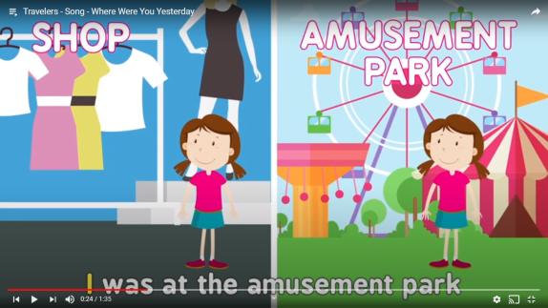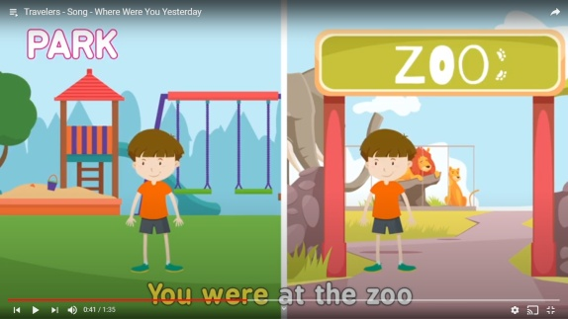
She was at the amusement park. He was at the Zoo.
She was at the shop. He was at the park.

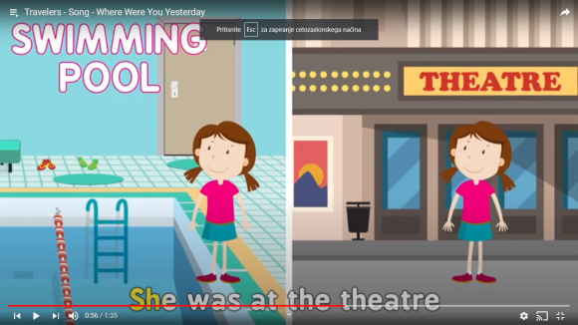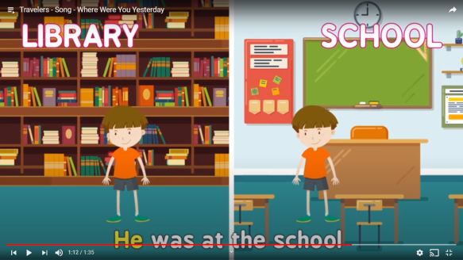
She was at the swimming pool. He was at the library.
She was at the theatre. He was at school.

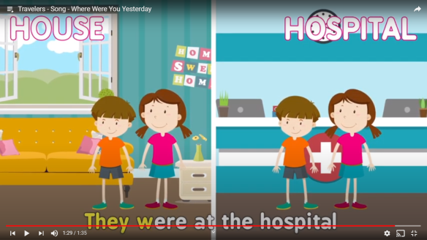 ZADAĆA: Nacrtajte gdje ste bili jučer i što ste radili
They were at home.
They were at the hospital.
( Ovo je množina, ima ih više, zato kažemo were )

