7a, 8a, engleski jezik, 25.5.-29.5.
Hello everybody !
Danas idemo na tržnicu – market. Na tržnici možete kupiti različite proizvode.
Pogledajte video i pročitajte tekst.
https://esol.britishcouncil.org/content/learners/skills/speaking/going-market
I like going to the market – you can buy lots of things there.
There’s a butcher’s stall, a fishmonger’s stall, lots of clothes stalls, a DVD stall and a magazine stall.
There’s a man who sells mobile phone accessories and one who fixes watches and cuts keys.
There’s a stall where I can buy all kinds of bits and bobs – like spare parts for my vacuum cleaner and other household appliances. (bits and bobs = od svega pomalo)
I especially like to buy my fruit and vegetables from the market. All the food is fresh and I can get value for money. There are lots of fruit and vegetable stalls, but I like Jason’s the best.
I go to his stall every Saturday. I tell him what I want and he puts it all into brown paper bags. He always has a special offer on. I try to go at the end of the day, when things are cheaper. I love to get a bargain! (bargain = povoljna kupovina)

Odgovoti na pitanja -Answer the questions:
1. How often do you go to the market?
2. What do you usually buy at the market?
3. Do you often buy from the same seller? (Why?)
4. What kind of things is sold at the market?
DOLAC MARKET
There is a famous market in Zagreb. It is called Dolac. Watch the video and read subtitles.
Write a short text about Dolac market In your notebook. ( Koristeći podnatpise napiši kratak sastavak o Dolac tržnici.)
https://www.lovezagreb.hr/zagreb-culture-vlogs/zagrebtrivia-dolac-market
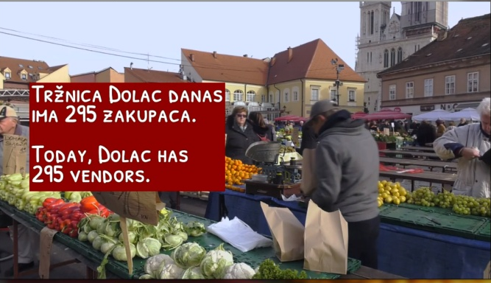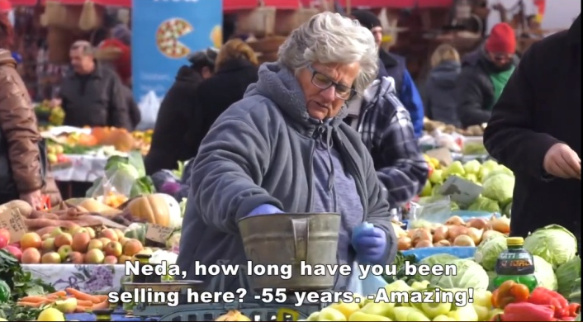

There are many famous markets in the world. One of them is The Spice Market in Istanbul.
https://www.youtube.com/watch?v=lI7o1ay_F-A
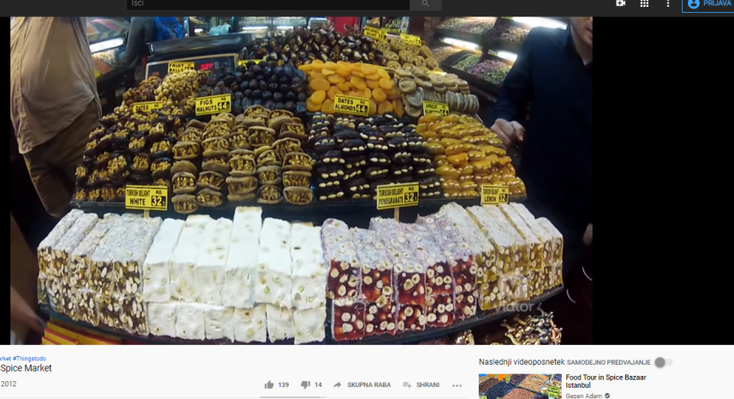
nuts
cheese
yogurt
baklava
spices
Turkish Delight
candies
sweets
Pogledaj nazive hrane o kojoj se govori. Poredaj nazive prema redoslijedu pojavljivanja.
ZADAĆA - 7 RAZRED
Otvori udžbenik na stranici 77., Across Cultures 6e, Markets Around the World.
Pročitaj tekst o tržnici u Corku, u Irskoj i tržnici u Istanbulu, u Turskoj. Napiši što možeš tamo kupiti.
The English Market, Cork | The Spice Market , Istanbul
I

ZADAĆA – 8 RAZRED Pročitajte ovaj strip o „mokrim tržnicama“. Wuhan Wet Market je jedna od njih.
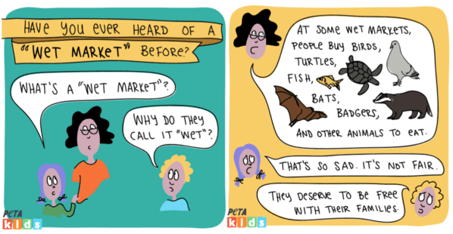

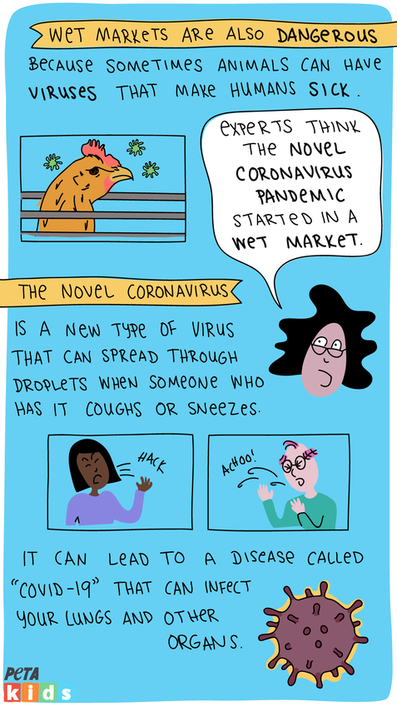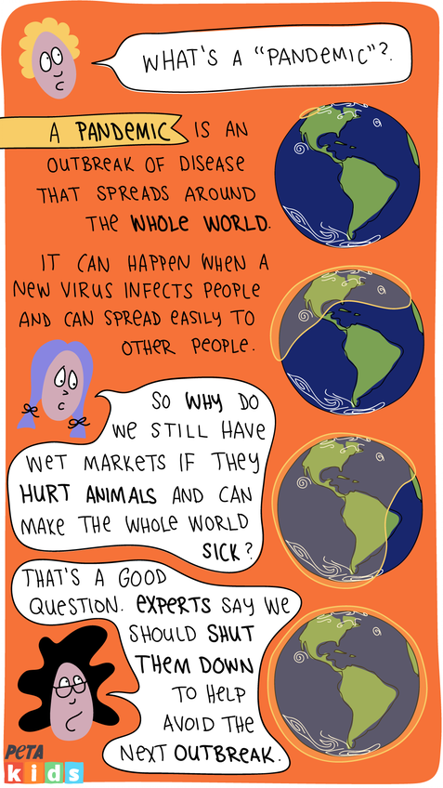
Ovaj strip je preuzet sa stranice PETA kids. PETA je organizacija koja se bori za zaštitu okoliša i human odnos prema životinjima. https://www.petakids.com/save-animals/wet-market-comic-strip/

