8a, engleski jezik, 11.5. – 15.5.
HELLO!
Još uvijek čekam vaše radove na temu okoliša. Pogledajte ovaj poster, pročitajte i razmislite.

REDUCE = smanji REUSE = ponovno upotrijebi RECYCLE = recikliraj

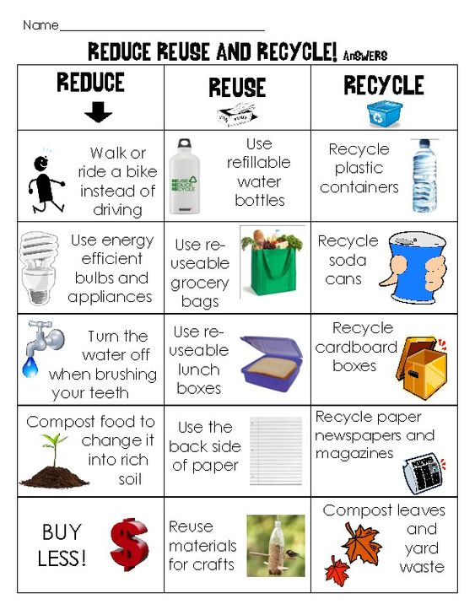
ZADAĆA: Što od ovoga vi radite? Napišite rečenice poput ovih mojih.
I use energy efficient bulbs. I don't compost food.
I use reusable grocery bags. I don't use reusable lunch boxes.
I reuse materials for crafts. I don't compost leaves and yard waste.
I recycle plastic containers.
I recycle paper.

Jučer je obilježen Međunarodni dan sestrinstva - International Nursing Day
What do nurses do? Što rade medicinske sestre?
1. What is her name?
2. Where does she work?
3. When does she start work?
4. What does she do in the hospital?
5. When does she go home?

FLORENCE NIGHTINGALE
Znate li tko je bila prva školovana medicinska sestra. Pogledajte ovaj video.
https://learnenglishkids.britishcouncil.org/short-stories/florence-nightingale
( Pritiskom na CC možete dobiti i tekst na engleskom jeziku ispod videa) Poznajete li ove riječi?
servant – sluga bandage – zavoj soldier – vojnik died – umrla je medal - medalja
Pročitaj ove rečenice i poredaj ih po redosljedu događanja. (Za Danijela: Prepiši rečenice u svoju bilježnicu.)
At night, Florence talked to the injured soldiers and helped the men to write letters.

In the Crimean War, there were no nurses in the army hospitals and many men died.

Florence Nightingale lived in the 19th century. She wanted to be a nurse and help people.

She continued to work hard in Britain to improve hospitals and she was given a medal.
In 1851, Florence went to Germany and learned about nursing.

Florence made the army hospital a cleaner and safer place, so fewer men died.

Ako vam je lakše , možete to uraditi i uz pomoć ovog teksta.

Ovi sadržaji su preuzeti sa British Council web stranice za učenje engleskog, za djecu.
https://learnenglishkids.britishcouncil.org
Imate puno priča poput ove, igara za učenje jezika , pjesmica i sl. Svakako pogledajte!!!

