3a, engleski jezik, 4.5.-8.5.
Danas ćemo prvo ponoviti različitu hranu, ono što volimo i ono što ne volimo.
Prepoznaješ li povrće. Sweet potato = slatki krumpir, asparagus = šparoge, lettuce =zelena salata ....

tomatoes onions asparagus broccoli sweet potato
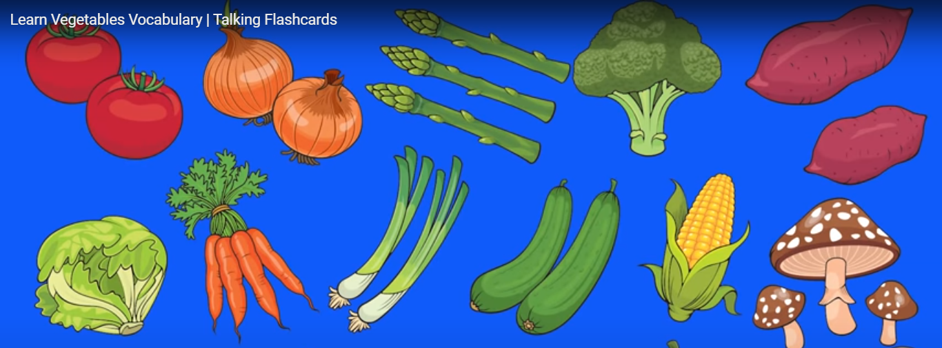
lettuce carrots green onions cucumbers corn mushrooms

pumpink beans eggplants green peppers potatoes

Pogledaj video i uvježbaj izgovor. Slušaj i ponavljaj. https://www.youtube.com/watch?v=bf6g9mkg-4o

Prepiši pitanje What's your favourite vegetable. Nacrtaj povrće koje voliš i napiši I like....
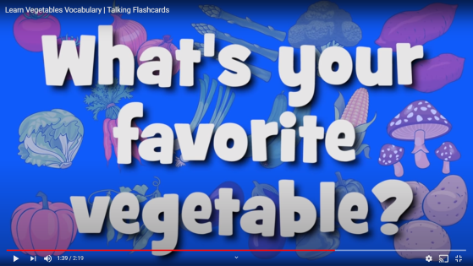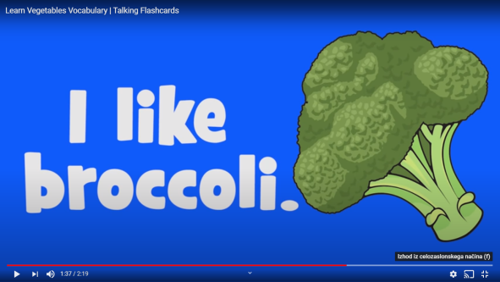
Uvježbajmo sada pitanja:
Do you like pizza? Yes, I do. No, I don't. Voliš li picu? Da, volim. Ne, ne volim.

Poslušaj ovu pjesmicu. Nauči pjevati.
https://www.youtube.com/watch?v=oEHiJsHFzLI

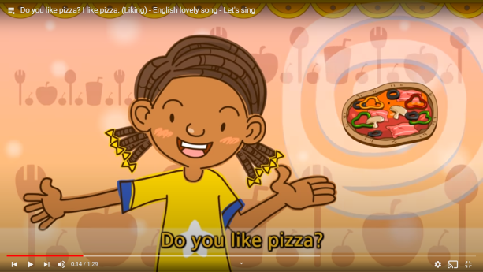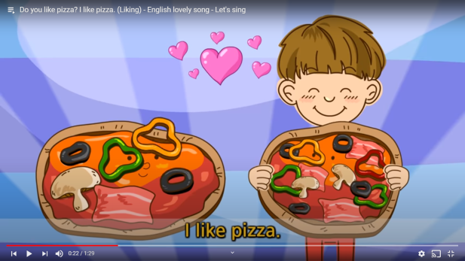
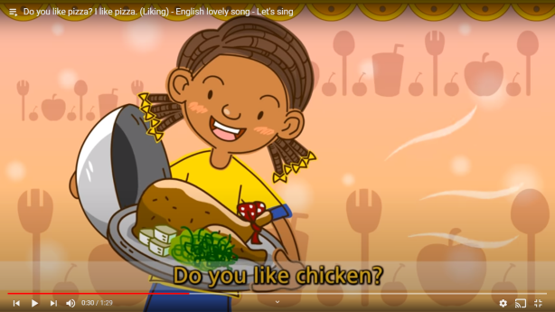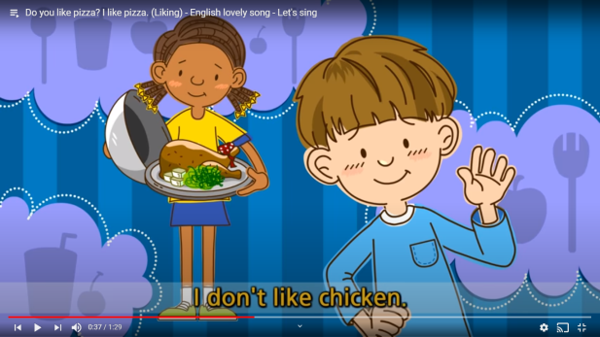

Dječak kaže: I like pizza. Ovo je prvo lice. Ja volim picu.
Mi govorimo o dječaku. He likes pizza. Ovo je treće lice. On voli picu.
U trećem licu glagol na kraju ima -s ili es.

Dječak kaže: I don't like chicken. Prvo lice.... Ja ne volim piletinu.
Mi govorimo o dječaku: He doesn't like chicken. Treće lice: On ne voli piletinu.

Prvo lice : I don't like Treće lice: He doesn't like She doesn't like...

Dobro pogledaj ovu sliku: Dopuni rečenice ispod slike riječima:
likes = voli doesnt'like = ne voli
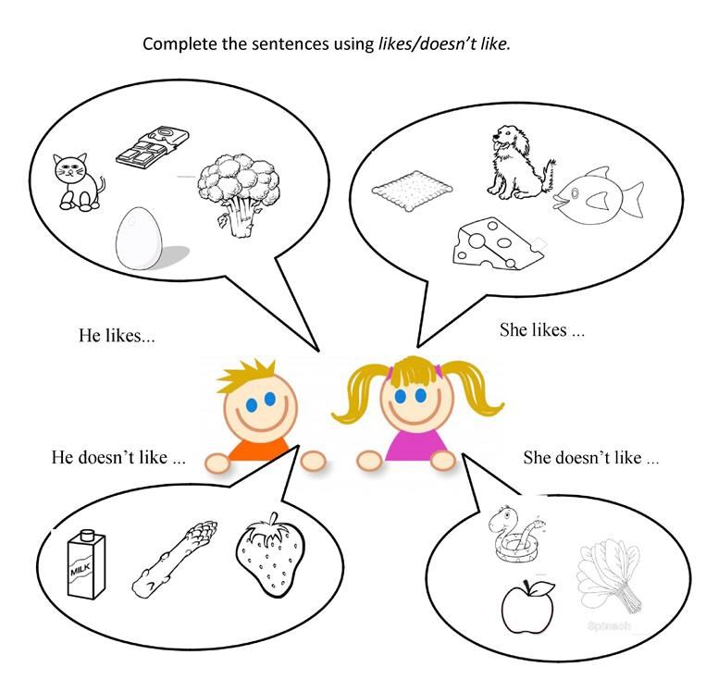
He ..likes............cats. She....likes................biscuits.
He.....................eggs. She...........................dogs.
He.....................chocolate. She............................fish.
He.....................broccoli. She............................cheese.

He .. doesn't like.......asparagus. She....doesn't like.....snakes.
He ...............................milk. She............................apples.
He...............................strawberries. She.............................spinach.

