Vode stajaćice I živi svijet u njima

Vode koje ne teku zovemo vode stajaćice

mora 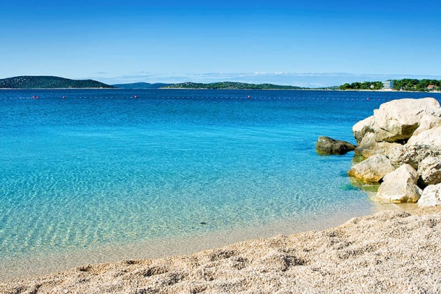

U i uz vode stajaćice žive mnoge životinje i rastu mnoge biljke

ŽIVOTINJE:

BILJKE:

