NA SLOVO, NA SLOVO

IMENUJ SVAKU SLIČICU.

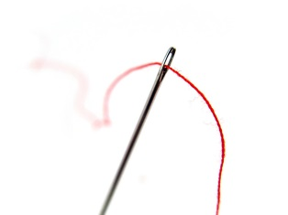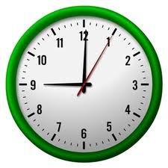

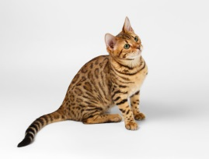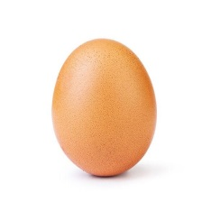

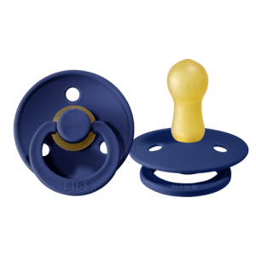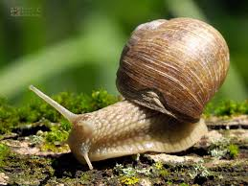

UZ SVAKO SLOVO ABECEDE NAPIŠI JEDNU RIJEČ SA SLIČICE KOJA POČINJE TIM SLOVOM. JEDNU RIJEČ NA TO SLOVO SMISLI SAM PA I NJU NAPIŠI.

A _______________________________________________________
B _______________________________________________________
D _______________________________________________________
I _______________________________________________________
J _______________________________________________________
K _______________________________________________________
M ______________________________________________________
O _______________________________________________________
P _______________________________________________________
R _______________________________________________________
S _______________________________________________________
U _______________________________________________________

