NAPIŠI RIJEČ OD TRI SLOVA.

kit2bor



**_________**

**_________**

lav

**_________**

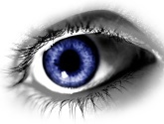**luk4**gol2koš5fenduhdom3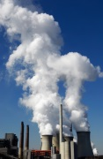bik3dar3

**_________**

**_________**

**_________**

**_________**

**_________**

**_________**

**_________**

**_________**

**_________**

**_________**

**_________**

**_________**

**_________**

