ANIMIRANI FILM

1. Kako se naziva film u kojemu animiramo lutke?
________________________________________________________

2. Kako se naziva film u kojemu animiramo crteže?
________________________________________________________

3. Navedi dva animirana lutkarska filma.
________________________________________________________
________________________________________________________

4. Navedi dva animirana crtana filma.
________________________________________________________
________________________________________________________

5. Rasporedi nazive filmova točno u kolone prema tome jesu li lutkarski ili crtani.

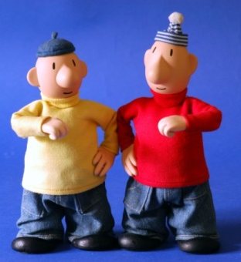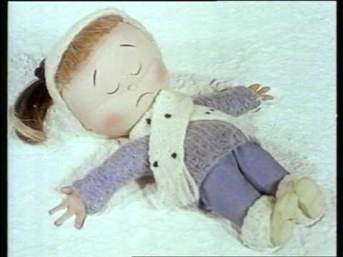
A je to! Profesor Baltazar Srce u snijegu
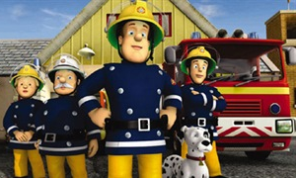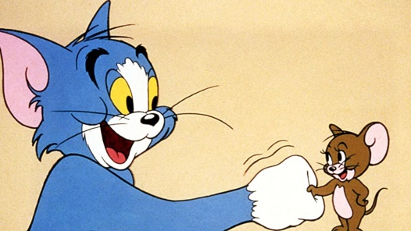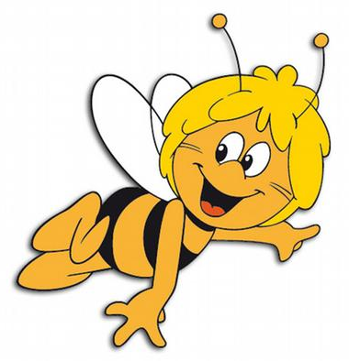
Vatrogasac Sam Tom i Jerry Pčelica Maja

LUTKARSKI FILMOVI | CRTANI FILMOVI
6. Koji je tvoj omiljeni animirani film?

__________________________________________________________

Je li taj film lutkarski ili crtani film?
__________________________________________________________

7. Pokušaj se sjetiti koje si sve crtane filmove pogledala kao mala/mali.

__________________________________________________________

__________________________________________________________

__________________________________________________________

- ČUDOVIŠNA PRIČA U PARIZU (CRTANI FILM)

- Koji se likovi pojavljuju u crtanom filmu?
Navedi sve kojih se sjećaš.

__________________________________________________________

__________________________________________________________

__________________________________________________________

__________________________________________________________

- Koja zanimanja imaju ti likovi?

__________________________________________________________

__________________________________________________________

_________________________________________________________
- Opiši izgled 2 lika (sam/sama odaberi).

__________________________________________________________

__________________________________________________________

__________________________________________________________

__________________________________________________________

__________________________________________________________

__________________________________________________________

- U kojem gradu se odvija priča?

__________________________________________________________

- Opiši glavnu radnju iz ovog crtanog filma (Tko se novi pojavio u gradu?, Tko je sve od likova lovio čudovište?, Tko je postao prijatelj s čudovištem?, Kako se završava priča?, Što se dogodilo s čudovištem na kraju?).

__________________________________________________________

__________________________________________________________

__________________________________________________________

__________________________________________________________

__________________________________________________________

__________________________________________________________

__________________________________________________________

__________________________________________________________

__________________________________________________________

- Da li je kraj priče sretan ili nesretan?

Da li bi ti promijenio/promijenila kraj priče?

Ako bi promijenio/promijenila, napiši kako bi izgledao.

__________________________________________________________

__________________________________________________________

__________________________________________________________

__________________________________________________________

__________________________________________________________

__________________________________________________________

__________________________________________________________

__________________________________________________________

__________________________________________________________

